Experiment Report of Digital System

Tests of Logic Gates

**- Name: Han Yichen 韩一尘**

**- Student ID: 22722051**

**- Date: 2023/09/13**

## 1. Aim

1. Familiar with the basic composition and functions of various parts of the digital circuit operation platform

2. Test and verify the functions of basic logic gates such as AND gate, NOT gate, OR gate, NOR gate, NAND gate, etc.

## 2. Content and steps

1. Carefully observe the composition of various parts of the digital circuit operation platform, and familiarize yourself with the functions and contents of each area;

2. Draw the truth table of AND gate, NOT gate, OR gate, NOR gate and NAND gate, and compare it with various models of chips on the operation box, and find the corresponding chips;

3. Connect the circuit;

4. Discuss and verify the output of logic gates under various input scenarios. And compare with the truth table.

## Circuit

1.AND gate:

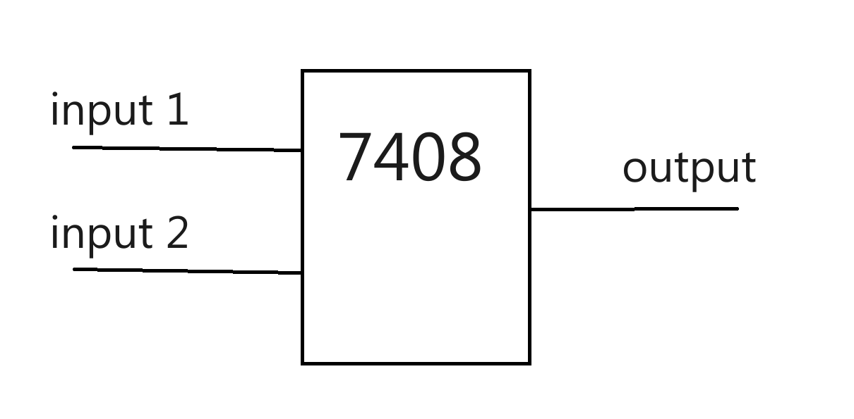

2. NOT gate:

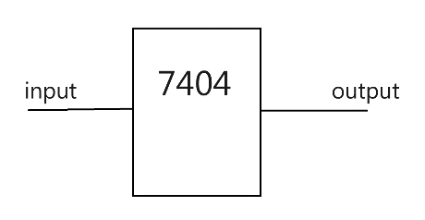

3. OR gate:

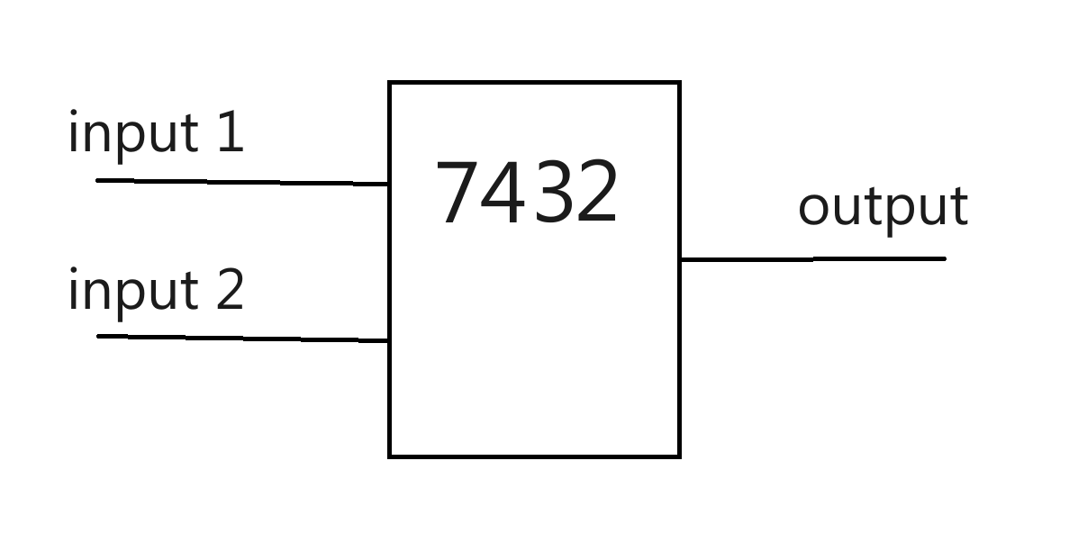

4. NOR gate:

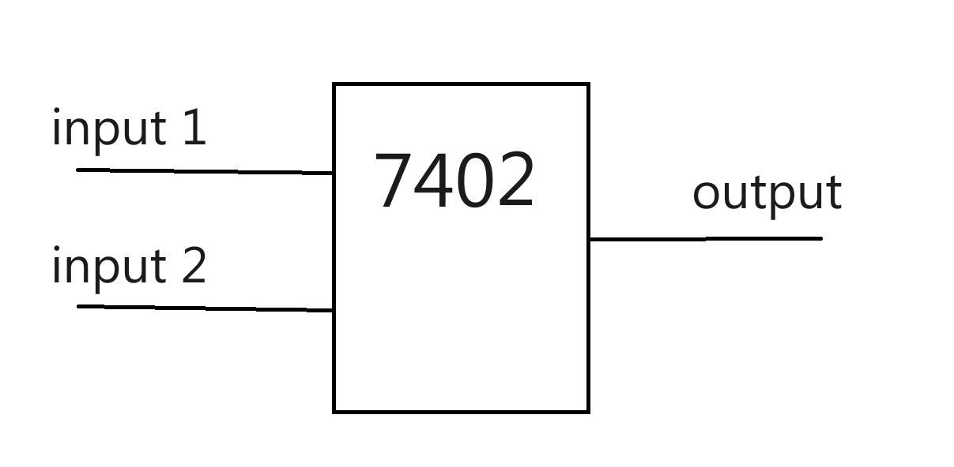

5. NAND gate:

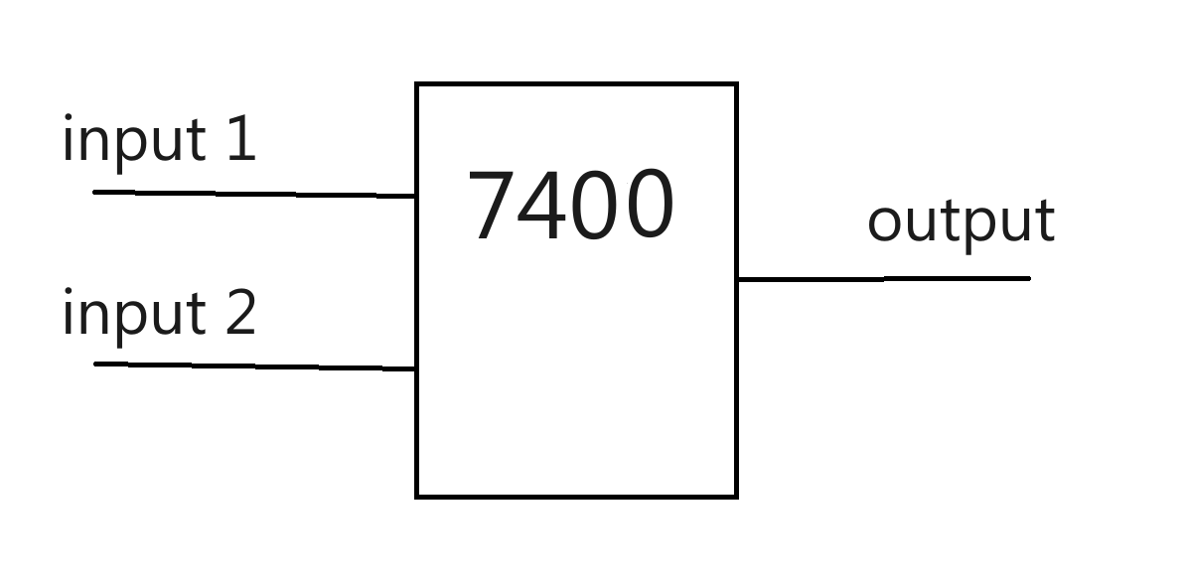

## Analysis

Firstly, we draw a truth table for each logic gate. Through testing, we can obtain different outputs. Record the truth tables of different chips in different situations and compare them with the truth tables of the logic gates we want to test, in order to obtain the chips corresponding to different logic gates.

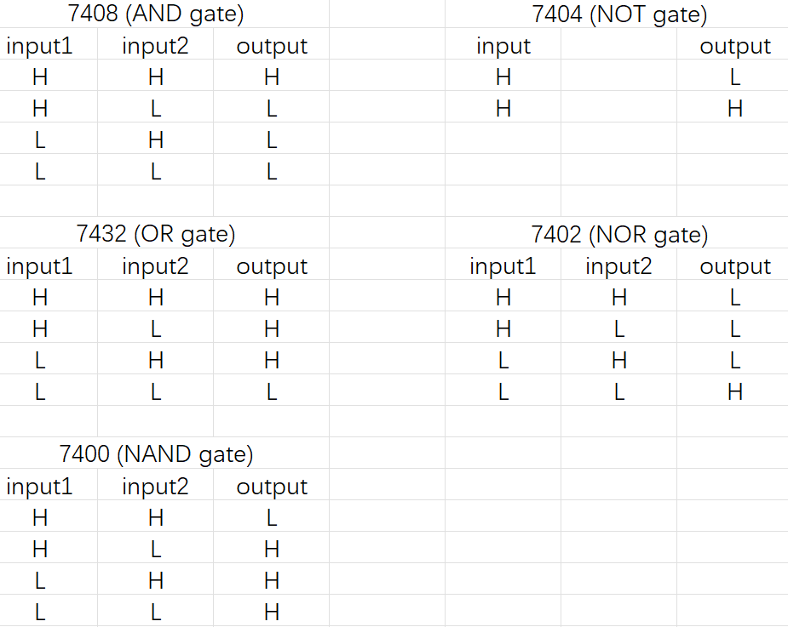

## Result

By testing in different situations of inputs on all kinds of chips, we can get a series of the outputs. As the truth tables recorded above, we have selected the ones that meet the requirements of the truth table, which mean we’ve find the AND gate, NOT gate, OR gate, NOR gate, NAND gate respectively, and the results of the truth tables are the same with what we respect. Therefore, the experiment is successful.